Gorley Vale Riding Club Newsletter
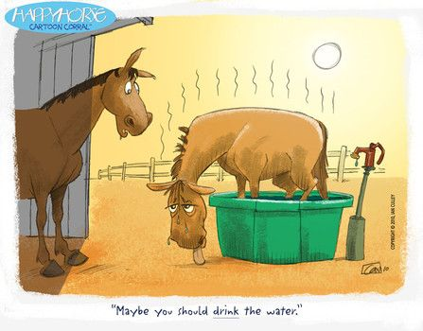
August 2022
Hi All. Hope you have all been getting out and about on your trusty steeds in this lovely (or is that unbearably!), hot, hot, hot weather!! Don’t forget to drop me a line if you have done anything exciting with your horse.

Here are a few things the club has done recently…

Stuff that’s happened…

Friday 24th to Sunday 26th June - Fun Camp at Brenda’s Fields, Burgate
Well, the annual Fun Camp has come and gone, but by all accounts it seems to have been a major success as usual. Well done Brenda and her little helpers!! Alex Taylor reported on Facebook:

“Super Day 1 at GVRC Camp – big thank you to everyone. Great ride in the morning (searching for letters/clues), a fab natural horsemanship demo with Tash and crazy clay pony making (which was hilarious!). The evening was fun with the potato pooping game back by popular demand, fantastic food provided by Jason at The Horse & Groom, a red arrow fly pass (which obviously the committee booked in advance!) and a campfire disco.
A great day 2 as well with pole/jumping lessons in the morning (with the lovely Trudi) and a really fun and interesting obstacle dressage test in the afternoon (being beautifully demonstrated by Brenda below and congratulations to Tanya who topped the leader board). We finished off with a cream tea and awards ceremony. It was great that everyone was thanked for making it such a fun

weekend, but especially the organisers and hostess. Well done Brenda! A fab weekend”

Sunday 7th August - Polework & Jumping Clinics, Folds Farm
This clinic was postponed from the 17th July due to the baking hot weather. In Cherie’s words, a massive well done to all the brilliant riders who came to Folds Farm. The sun shone, the ponies all worked hard and there were lots of smiles, fun and achievements.
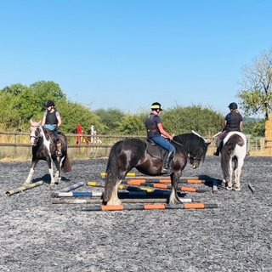
Sally Gibbs, who attended, commented on Facebook:
“Thank you to Nikki Green for her lovely encouraging teaching style. Also, thanks to Cherie for organising and looking after everybody so well”

Saturday 20th August - Tack Sale/Equestrian Car Boot, Brenda’s Fields, Burgate
A big thank you to Jo who organised the tack sale, which ran
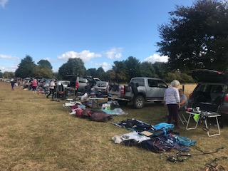
very smoothly. We had well over 20 sellers so there were
lots of bargains to be had, although we could have done with
a few more buyers!! If you didn’t come along, please let us
have feedback as to why. You really missed a treat, parti-
cularly Debbie’s fabulous homemade cakes – they were yummy!!
Thanks Debbie.

Stuff that’s happening…
Saturday 3rd September – Hampshire Horse Agility Clinic, Hockey’s Farm, Gorley
If you are interested in this one, you will have to be quick. Only a few spaces remain, so please contact Cherie (greencherry.68@btinternet.com) now! This is an in-hand clinic and GVRC has booked three 1 hour sessions with 4 people in each: 10am (fully booked), 11.15am (2 spaces available) and 12.30pm (1 space left). There will be plenty of obstacles to challenge you and your horse. Andrew did this recently with Trooper and he can highly recommend it! £35 per handler/horse (Ref: Horse Agility).

Tuesday 13th September - Polework /Jumping Clinics, Brenda’s Fields, Burgate
We thought we would sneak in a cheeky Autumn evening Clinic aimed at all levels with the fantastic Trudi. If you haven’t tried one of our clinics before, please give it a go! Trudi is lovely and very encouraging and everyone is supportive. The start time is 5.30pm, with a second at 6.30pm (dependent on numbers). The cost is £15 per person (Ref: Trudi Clinic). To book, please contact Tina (tinawhittet@btinternet.com)

Sunday 9th October – Massage Clinic at Tom’s Field, Godshill
As the demonstration on Equine Massage with Louise earlier in the year proved so popular, we are planning to hold another! Bring your own horse to be massaged for £10 or come and watch for a small donation on the day. (Ref: Massage Demo). Contact: Debbie (debjcooke16@gmail.com)
Saturday 29th October – Emma Massingale Performance at Kingston Maurward Equestrian, Dorchester
Although not a GVRC event as such, we thought we would let you know that some committee members are interested in going to see Emma Massingale, a free rider/adventurer who works with herds of horses at liberty – her motto: No reins No rules No limits. Starting at 3pm, it will be a couple of hours of fun and entertainment, watching Emma and her amazing horses at work, rest and play. Café/refreshments are available. Tickets are £35 each, available from her website (www.emmamassingale.com). Make your own way there or if you would like to car share, please contact Sharon (Sharon.rupertbear@hotmail.co.uk) and we will try to arrange it.

Sunday 30th October – Spooky Halloween Gathering, Greenfields, North Gorley

Get your spooktacular costumes at the ready and prepare for fun and games!! You can ride to it (weather dependent), come by car or broomstick – choose your poison! Bat soup and evil cakes (by evil we mean calorie laden!) provided. Cost to be confirmed (Ref: Halloween). Contact: Tanya (sunshine.gardens@yahoo.co.uk)

Thursday 10th November – Annual General Meeting
Come and join us for the AGM. We promise to keep the meeting as short as possible (as usual) and then have a lovely social gathering with meal included. Details to follow.

Saturday 19th November – Alternative Valentine’s Ride at Redlynch
As you may remember, Wendy organised a Valentine’s Ride in February which we unfortunately had to cancel due to the weather. Instead of waiting until 2023, we

thought we would hold it now! Come and enjoy a fun ride at Redlynch with chocolates and prosecco! Armed with a map and a clearly marked route of the tracks and grassy bridleways on the downs, you can enjoy the ride at your own pace in pairs or small groups. Time slots and parking to be confirmed. £5 per person (Ref: Valentines Ride). Contact: Wendy (wtreble@btinternet.com)

Saturday 10th December - Christmas Gathering
Get the date in your diary and your tinsel and fancy dress outfits ready for this festive social pub ride! Venue and further details to be confirmed.

Still to come…
Other possible events in the pipeline for this year are:
- Dog Agility Demo and Have a Go session with Ande (a newish member who happens to compete at dog agility for the British team!) Watch this space!!
- Driving Demo/Experience with the Sampsons

And finally…
Very sadly, Debbie (our wonderful treasurer) has decided to step down at the AGM, although she will remain on the committee. We would like to take this opportunity to thank her for all her hard work over the years. Obviously, this means that the position of Treasurer is now up for grabs, so if you have any ambitions to become the next one, perhaps chat to Debbie about what is involved and let someone on the committee know.

In addition, our Interim Chairperson, Andrew, would like to step down too as he only took the role on to cover Pauline’s departure. However, we are trying our best to persuade him to stay a little longer!! We have also decided that ideally we need a PR/Advertising/Website Person on the Committee, so if you are a techno whizz, why not join us!

Lastly, on a different subject, it won’t be long before Membership Fees for 2023 are due – where is the year going? We are keeping the cost the same as last year, i.e. £23 per person. Please make payment into the GVRC account (Ref: Membership) before the AGM on 10th November.

Ta Folks. Happy Riding!
Sharon x

Bank details for payments are as follows…
Sort code: 30-97-08 Account no: 01404126
Please make sure you put the appropriate reference otherwise it is exceedingly difficult for Debbie to keep track of who has paid what for when!!!

