Gorley Vale Riding Club Newsletter
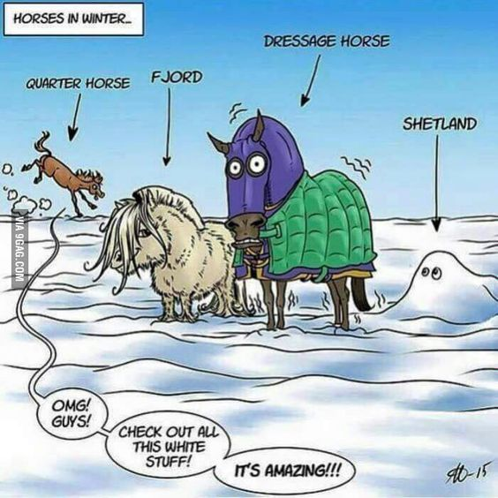
December 2022
Well, Winter is well and truly here, but that hasn’t stopped us from getting out and about and having fun!

Here are a few things the club has done recently…

Stuff that’s happened…

Saturday 29th October – Emma Massingale Performance at Kingston Maurward Equestrian, Dorchester
About a dozen GVRC members, myself and Andrew included, went to see Emma Massingale, a free rider/adventurer who says her work with horses is her passion and her love. Horses amaze and inspire her on a daily basis, with compassion, imagination and a sense of fun, she believes there is no limit to what is possible.
Although making our way in 4 vehicles, we all soon met up in the queue for the burger van outside! Got to get your priorities right! The event began with Emma bringing into the arena her cute shetlands and a mule. As she got them to follow her on her Segway through various obstacles, she explained how she started them on long reins and progressed to liberty work on the ground as their connection grew.

She then introduced her connemaras, demonstrating the ease with which she could control her four ponies at once, riding four abreast and following in pairs. She had them standing on a raised platform and even sitting on a beanbag! As a trainer, she undoubtedly has a special gift and her ponies are treated with the utmost kindness and respect. If you ever get the chance to see her, she comes highly recommended!

Sunday 30th October – Spooky Halloween Gathering, Greenfields, North Gorley



Our members never let us down and once again, they dressed up and rode or made their way by other means to Greenfields. Tanya would like to say a big thank you to everyone who attended and, judging from the photos, it seems that fun was had by all! Here are some of the comments made by members:
“Everyone was a winner. Was so nice to see everybody and have a catch up. Tanya’s cooking was excellent as ever!” (Tina)
“Fun games and fabulous soup” (Brenda)
“Good fun. Thank you Tanya and Tina” (Wendy)
“Thank you so much for the delicious soup and for accom-modating my eating needs. It was very much appreciated. Really fun games and thanks to all who chose me as the fancy dress winner. I had so much fun!” (Sandra)

Thursday 10th November – Annual General Meeting, The Horse & Groom, Woodgreen
There was a fantastic turnout for the AGM with 29 members in attendance. Andrew, our acting Chairman, welcomed everybody and did a quick run through of all the events held in 2022. Phew what a lot we have done! It was agreed that our charitable donations of £100 each would go to:

- Hampshire Spirit Horse Rescue – a small local charity
- Caring in Bristol – helping homeless people
- Lucy Fensom – A donkey, horse & dog charity based in Israel, run by a UK person

With regards to the election of officers, Andrew (slightly reluctantly) agreed to stay on as Chairman, Cherie as Secretary and Wendy as Membership Officer. Sadly, our wonderful Treasurer of many years, Debbie, has decided to step down although will remain on the committee. Andrew presented her with a card and voucher in recognition of all her hard work. Unfortunately, nobody came forward to take over as Treasurer on the night, so this will be discussed at the next committee meeting. The other committee members (Tina, Tanya, Brenda, Sharon, Sue and Jo) will remain the same.

Finally, Tina (in her own unique style) distributed the herd of clay horses that had been made at camp that had been proudly on display throughout the evening. Surprisingly, they looked better than expected, even though many repairs and firings were required I believe!

Once the formalities had been concluded, we could all relax and enjoy the delicious meal – The Horse & Groom definitely did us proud! After which, everyone had a jolly good catch up. Personally, I was slightly too relaxed – I forgot to take photos, oops!! I blame the morphine!

Saturday 19th November – Alternative Valentine’s Ride at Redlynch
Well done to Wendy for organising a fabulous fun ride which everyone seemed to enjoy! Here is Marlies’ account of the event: “On Saturday 19th November the long-awaited Valentine’s Ride finally went ahead at Redlynch, having been cancelled back in February due to the bad weather. Luckily the weather gods were kind this time and it turned out to be a beautiful morning for the 6-mile outing.

Everything was very well organised by Wendy and Sandra, who not only provided directions, route maps and route markers, but also treated everyone to coffee, sweets and even a glass of Prosecco! Sue and I were out first - Sue and Duchess already having hacked for well over an hour to get to the starting point! Alex, Sarah and Tina followed suit and everyone had a great time, enjoying the great tracks and stunning views across the countryside with Salisbury Cathedral and Fawley in the distance. The ponies all braved the guineafowl at the cottage and everyone got back safe and sound, ready for the next adventure.”

Stuff that’s happening…
Saturday 10th December - Christmas Gathering, The Alice Lisle Pub, Rockford

ONLY 3 DAYS LEFT TO BOOK YOUR PLACE!! Fortunately, we have had a reprieve! As our event is at the pub, it is up to you how you travel to it – no permits required…HOORAH!! Come and join us at 12 noon (with or without your ponies) and, as usual, fancy dress is encouraged. Partners also welcome. It’s great value at £12 per person (Ref: Xmas) for a bap, chips and a mulled wine. The choice of baps is:
- Cured Ham & Chutney
- Battered Haddock Fingers with Tartare Sauce
- Pulled Chicken, BBQ Sauce & Slaw
- Slow roasted Tomato, Rocket & Truffle Aioli
Contact Sharon (Sharon.rupertbear@hotmail.co.uk) by Sunday 4th December LATEST please to book your place and choose your food.

And finally…
If you are not already a fully paid up member for 2023, please get your Membership Fees in NOW! Being held at the 2022 rate of £23 per person, I’m sure you will agree that it’s great value for money. Please make payment into the GVRC account (Ref: Membership). Wendy, our lovely membership secretary, has to get a list of members’ details to the BRC shortly, so don’t miss out!!

Bank details for payments are as follows…
Sort code: 30-97-08 Account no: 01404126
Please make sure you put the appropriate reference otherwise it is exceedingly difficult for our Treasurer to keep track of who has paid what for when!!!

