Gorley Vale Riding Club Newsletter
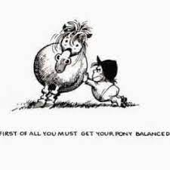
June 2022
Hi All. Since the last newsletter, there has sadly been a change to the committee. Pauline Grant has decided to step down from her position as Chair, but we would like to send her our thanks for her valued input.

However, Andrew Gray, my lovely hubby (got to say that as he now signs the newsletter off!!), has stepped in as interim Chairperson. Who knows, if we buy him a few drinks at the AGM, he may be persuaded to stay on…

Stuff that’s happened…

Saturday 7th May - Coach Trip to Badminton Horse Trials
Despite the huge crowds (110,000 people and sold out for the first time ever!), everyone had a great time at Badminton and the weather was glorious.
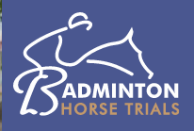

We were picked up bright and early by the minibus from Trollope Transport (yes, the comments made on Facebook were true) and here is the evidence to prove it. We will leave it to you to decide whether you feel this is appropriate or not!
We made it round most of the course, marvelling at the huge jumps and insane angles. Jo got a great shot of William Fox-Pitt, while the rest of us were lucky to actually get a horse in the photo. I vote she becomes official photographer for the club!
Eating, drinking and plenty of shopping (some spending more than others – naming no names!) made it the perfect day.
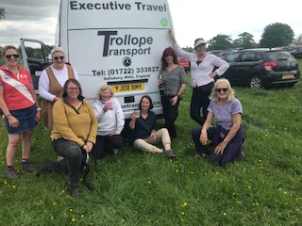

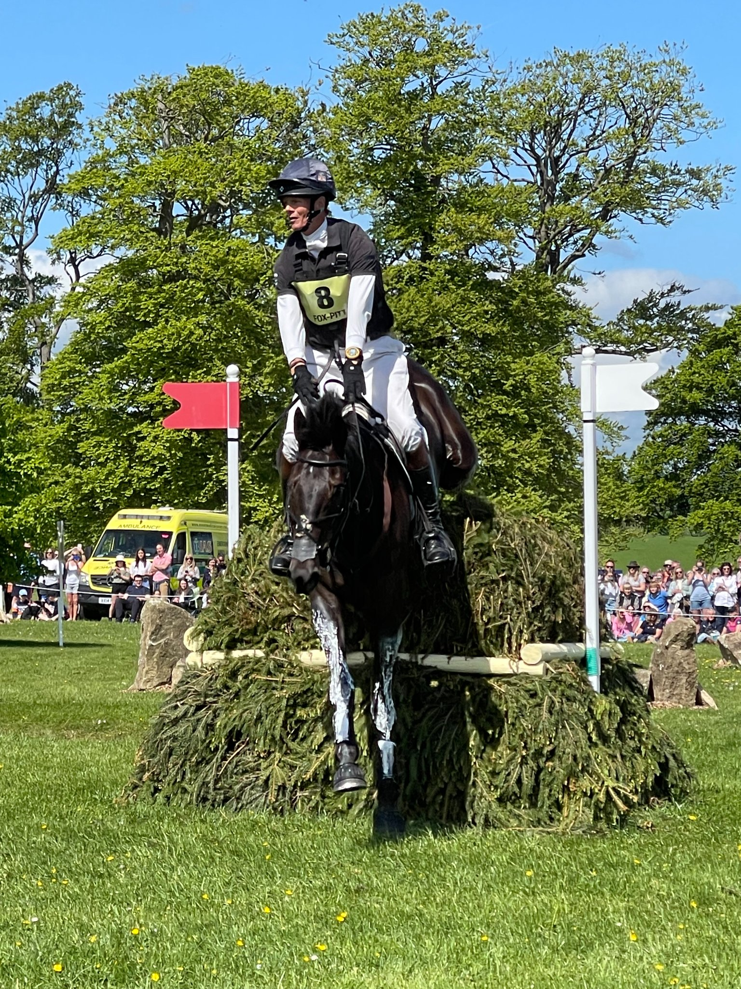
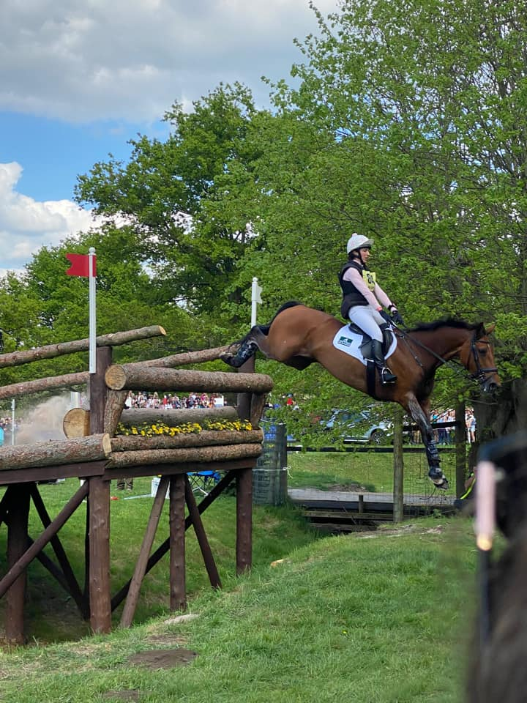

Saturday 21st May - Polework & Jumping Clinics, Wick Farm, Downton
Firstly, our thanks go to Anna Noble for her interesting and fun Polework and Jumping Clinics and for her encouragement and brilliant training, which got our members to perform at their best. Brenda, Sue and Wendy made up the first group and their horses soon settled over the poles and they progressed to a round of jumps which got them thinking. Nemo (Brenda’s baby) did fantastically well – you could almost see his brain ticking over as he worked it all out!
Marie Witt and Sandra Pollard did the next Polework Clinic and Sandra put a lovely post on Facebook: “Thank you Sue for organising a lovely pole clinic this morning. My first ever event on horseback! Big thank you to the GVRC members attending for being so friendly and supportive throughout. It really meant a lot to a very anxious middle-aged lady whose legs were feeling very wobbly at the start! Also to Anna Noble who gently pushed me out of my comfort zone to achieve my goal. Looking forward to the summer ahead!”

Arthur, Marie’s cool dude of a cob, decided he would much rather do the Jumping Clinic next time! (see pic above)
Stuff that’s happening…
Friday 24th to Sunday 26th June - Fun Camp at Brenda’s Fields, Burgate
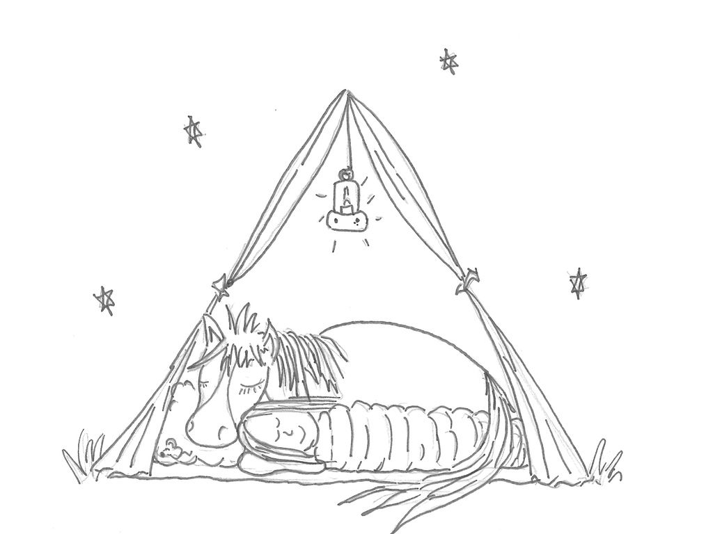
ROLL UP, ROLL UP! Any more takers for camp? Please come and join us for a fun, relaxed time with no pressure. If transport is an issue, please contact a committee member for help.

A few small changes to the schedule are listed below:

Arrive on Friday afternoon/evening to set up corrals and settle down for a self-funded takeaway and a few bevvies and a catch up OR turn up on Saturday morning.

Saturday will be a fun day incorporating:
- An Anagram Ride (Hack out on a letter hunt and solve the mystery word/phrase)
- Obstacle practice with Brenda
- Natural Horsemanship talk/Liberty demo with Tash (content TBC)
- Tina’s craft corner
- Instead of a BBQ, we thought everyone deserved the evening off, so Jason at The Horse & Groom will deliver a fantastic range of takeaway meals. Brenda will send a menu for you to choose from beforehand when you book your place.

NB: All members and their families are welcome to come and join us for a drink and/or food and fun on the Saturday evening. The meals are great value at £12 per head. It would be lovely to see you all! Just let Brenda know if you can come along.

If you still have plenty of energy on Sunday, there will be:
- Polework and jumping clinics with our lovely instructor Trudi
- Dressage with obstacles competition
- Afternoon cream tea with rosette presentations

The cost is £80 per person (Ref: Camp) and to book your place, please contact Brenda on 07803 387560 or email pootlin@hotmail.com

Sunday 17th July - Polework & Jumping Clinics, Folds Farm
Choose from a Polework Clinic offering some interesting gridwork or a Jumping Clinic if you are feeling brave, with the lovely Nikki Green. £18 each (Ref: Nikki Green). If you are interested, please contact Cherie ASAP (greencherry.68@btinternet.com)

Late July/Beginning of August – Driving Experience at the Sampsons, Harbridge
The Sampsons have kindly invited us again to join them for an evening demo and to have a go driving. It was great fun last time, so watch this space/facebook for a date to be confirmed. The contact for this one is Tina (tinawhittet@btinternet.com)

Saturday 13th August - Polework & Jumping Clinics, Wick Farm, Downton
As the clinics in July were popular and much enjoyed, we have decided to run further Polework and Jumping Clinics aimed at all levels with the lovely Anna Noble. She is a fantastic teacher and very encouraging, so why not come and give it a go! The cost is £20 per person (Ref: Anna Noble). Please contact Sue (sue.vass.email@gmail.com) to book your place.

Saturday 20th August - Tack Sale/Equestrian Car Boot, Brenda’s Field, Burgate
From 10am to 1pm, come and grab a bargain at our Tack Sale at Brenda’s field. This will be opened to the general public so if you have any horsey friends who are totally overstocked or in need of items, please let them know. Cake and refreshments will be available of course!! £5 per table (Ref: Tack Sale). Contact: Jo (jo@thehouseoflawrence.com)

Saturday 3rd September – Hampshire Horse Agility Clinic, Hockey’s Farm, Gorley
Hampshire Horse Agility is running a full day of in-hand clinics and has offered GVRC three 1 hour sessions with 4 people in each. There will be plenty of obstacles to challenge you and your horse. Andrew did this recently with Trooper and he can highly recommend it! £35 per handler/horse (Ref: Horse Agility). If you are interested, please contact Cherie (greencherry.68@btinternet.com)

Sunday 30th October – Spooky Halloween Gathering, Greenfields, North Gorley

Get your spooktacular costumes at the ready and prepare for fun and games!! You can ride to it, come by car or broomstick – choose your poison! Bat soup and evil cakes (by evil we mean calorie laden!) provided. Cost to be confirmed (Ref: Halloween). Contact: Tanya (sunshine.gardens@yahoo.co.uk)

Still to come…
Other possible events in the pipeline for this year include…
- Dog Agility Demo and perhaps have a go session with Ande (a newish member who happens to compete at dog agility for the British team!)
- Cross country schooling at Tenantry
- Your Horse Live coach trip
- Equine simulator
- Christmas Gathering
…Amongst others!! Watch this space.

And finally…
The Bramshaw Adult Group of the Riding for the Disabled Association are on the lookout for a suitable new horse…

Do you own a horse which is a kind, steady soul who would fit into an RDA environment, or know someone who does? It would need to stand beautifully at the mounting block, be happy to be led and have side walkers and not be fazed if a rider becomes slightly unbalanced – a real beginner’s type. The RDA holds the session on a Friday morning from 10am to 12 noon at Godshill. If you think you can help by lending your horse, please contact Anne Agapiou on 07821 288365 for details.

Enjoy the sunshine!
Sharon x

Bank details for payments are as follows…
Sort code: 30-97-08 Account no: 01404126
Please make sure you put the appropriate reference otherwise it is exceedingly difficult for Debbie, our wonderful treasurer, to keep track of who has paid what for when!!!

