Gorley Vale Riding Club Newsletter
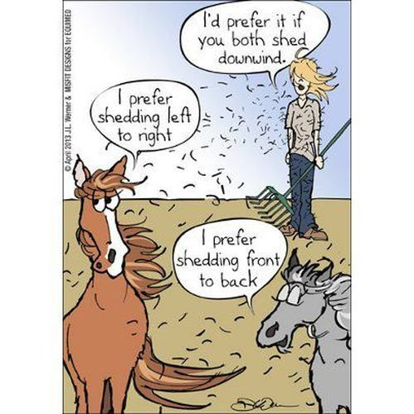
March 2022
Hi All. Spring has finally sprung and hopefully the weather will reflect this and we can all begin to get out and about with our trusty (or not so trusty!) steeds. There are no excuses, as we have plenty of events planned…

Stuff that’s happened…

Sunday 13th February - Valentines ride at Redlynch
Well the weather beat us again and unfortunately we had to cancel this ride. Broken hearts all round!! But don’t worry, the route is planned so we will aim to do is again later in the year. Watch this space…

Friday 25th February - Film Night at Tanya’s, Greenfields, North Gorley
Tanya would like to thank everyone who came along to the film night and apologises for the Wi-Fi issues. Although I don’t think anybody minded if this is what Gina Hemmings had to say about the evening…..
“Cosy and snug in Tanya’s lovely barn with the wood burner glowing, popcorn to hand and a glass of something warming (depending on a preference of method; alcohol or heat), about a dozen of us settled into an array of comfy sofas to watch The Eagle Huntress. Meanwhile, due to the unusually intermittent Wi-Fi, the very lovely resident aerial mast by the name of Andrew stood up a ladder outside with arm raised high to the stars to find some elusive signal to enable us to watch the film. What a star he is!!

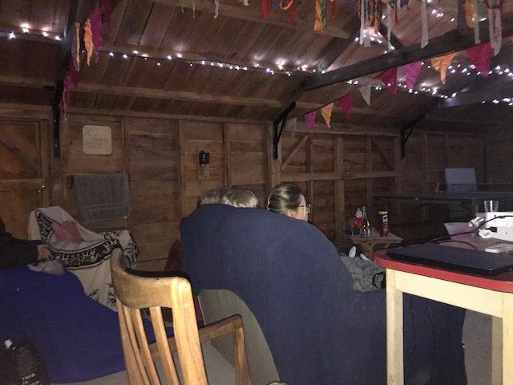
The film was a great choice (thank you Brenda) - I thoroughly recommend it if you haven’t seen it yet. In fact, I got my whole family to watch it a few days later - and they all enjoyed it too. Apart from they’re worried if my next midlife crisis will involve an eagle!
Once the film had finished we all stayed for a while in the toasty barn having a good old catch up. Thank you so much to Tanya, Andrew and family for hosting us all and making us feel so welcome. Looking forward to the next film night….. (sorry Andrew)”

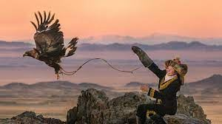

Stuff that’s happening…
Sunday 6th March – Dressage Pilates Clinic, Folds Farm
Helen Dawes will be holding a Dressage Pilates Clinic at Folds Farm. Pilates on horseback to improve position and effectiveness with exercises that you can continue after the lesson. £30 per person (Ref: Pilates Clinic). Contact: Pauline (paulinegrant@utilitywarehouse.org.uk)
Saturday 26th March – Fun Quiz at Greenfields, North Gorley
Get your brains ticking over with our quizmaster extraordinaire Andrew. Always a fun evening, with pizza and a raffle in aid of the Ukraine Crisis. Teams of up to 6. £8 per person (Ref: Quiz) Contact: Tanya (sunshine.gardens@yahoo.co.uk)

Saturday 9th April – Equine Massage Demo at Cherie’s Yard Brunes Perlieu Lane
Louise Cooke has kindly agreed to do a demonstration on Equine Massage. Bring your own horse to be massaged for £10 or come and watch for free. (Ref: Massage Demo). Contact: Debbie (debjcooke16@gmail.com)
Saturday 30th April – Bluebell Ride, Burgate
Meet at Brenda’s field and enjoy a Fun Ride and admire the bluebells on the way! This will be a 1.5 hour ride maximum and will cater for all levels/speeds. This is a FREE event, so come on guys – make the most of it and contact Brenda (pootlin@hotmail.com) to let her know numbers.
Saturday 7th May - Coach Trip to Badminton Horse Trials
We are hoping to run a coach trip on the Cross Country day of Badminton Horse
Trials. The BRC are offering discounted tickets for group bookings.

The cost would be £60 each to include entry ticket and travel by bus (Ref: Badminton). However, tickets have to be booked before the end of March to get the discounted rate, so please can you let Debbie (debjcooke16@gmail.com) know as soon as possible if you are interested.

Saturday 21st May - Polework & Jumping Clinics, Wick Farm, Downton
Polework and jumping clinics with Anna Noble to suit all levels. The cost is £20 per person (Ref: Anna Noble). Please contact Sue (sue.vass.email@gmail.com) to book your place.

Friday 24th to Sunday 26th June - Fun Camp
Calling all campers! Reserve the date as our ever popular Fun Camp returns. Demos, dressage, liberty work…..who knows? Details to follow in due course.

Sunday 17th July - Polework & Jumping Clinics, Folds Farm
Choose from a Polework Clinic offering some interesting gridwork or a Jumping Clinic if you are feeling brave, with the lovely Nikki Green. To be held at Folds Farm. £18 each (Ref: Nikki Green). If you are interested, please contact Cherie (greencherry.68@btinternet.com)

Saturday 20th August - Tack Sale/Equestrian Car Boot, Burgate
Come and grab a bargain at our Tack Sale at Brenda’s field. This will be opened to the general public so if you have any horsey friends who are totally overstocked or in need of items, please let them know. Cake and refreshments will be available of course!! Time to be confirmed. £5 per table (Ref: Tack Sale). Contact: Jo (jo@thehouseoflawrence.com)

Sunday 30th October – Spooky Halloween Gathering, Greenfields, North Gorley
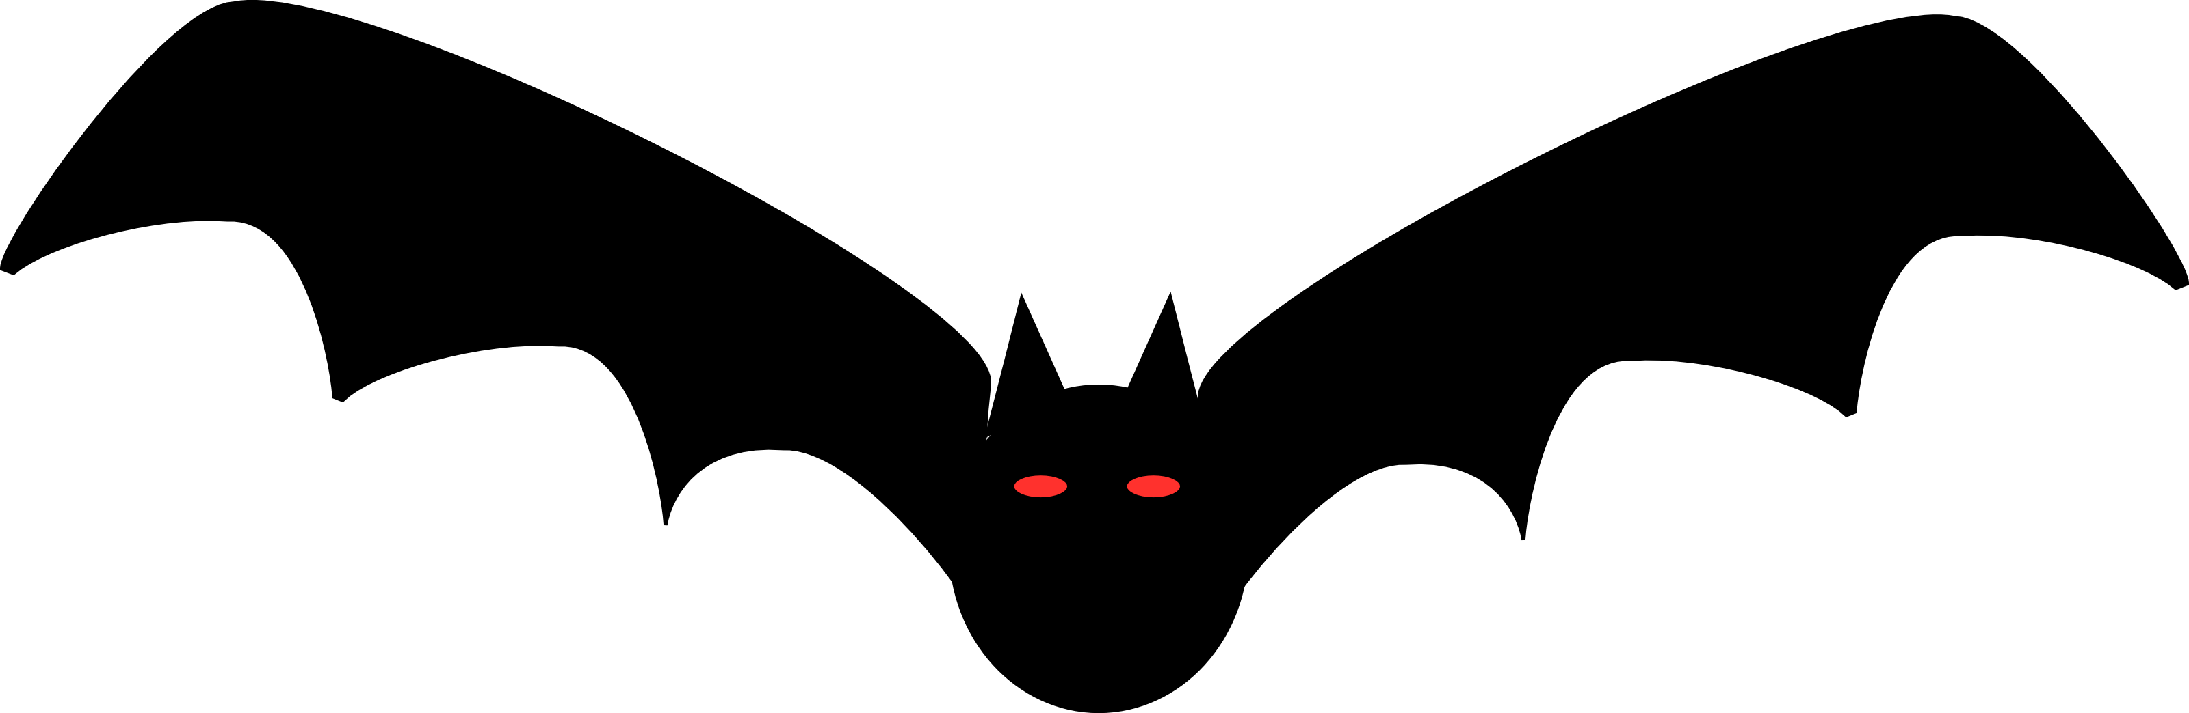

Get your spooktacular costumes at the ready and prepare for fun and games!! You can ride to it, come by car or broomstick – choose your poison! Bat soup and evil cakes (by evil we mean calorie laden!) provided. Cost to be confirmed (Ref: Halloween). Contact: Tanya (sunshine.gardens@yahoo.co.uk)

Still to come…
Other events in the pipeline for this year include…
- a visit to the Sampsons to hone our driving skills
- Cross country schooling at Tenantry
- Horse agility
- Your Horse Live coach trip
- Equine simulator
- Christmas Gathering
…Amongst others!! Watch this space.

And finally…
Challenge Gorley Valers!!
We hope you enjoyed trying out the "just for fun" challenges in the last newsletter. Debbie has come up with a couple more to keep you going, but this time she has given a few tips to help you....
Non ridden - Ground tie your horse
Drop your rope on the floor and walk away from your horse while they stand still. If this is something new to you and your horse, you might start with dropping the rope on the ground and walk slowly round your horse keeping your hand on them as you go.
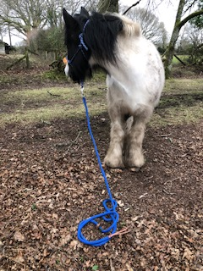
If you already do this with your horse, try walking farther away or leaving ground tied for a little longer. See how far you can get.

If you want it to be more challenging, try jogging around your horse or waving a flag or some other distraction while they remain still.

The pic to the left shows the lovely Tonto demonstrating – “Where have you gone Mum??”

Ridden - Ride your horse sideways along a fence

Ride to the fence and with your horse's nose at the fence, ask them to move sideways for a couple of steps. If you have not tried this before, you may want to start on the ground using your hand as the aid in place of your leg.

If you are asking your horse to move right, place your left hand at their face with your fingers just lightly through the bridle to help keep their nose on the rail. Place your flat hand (palm against the horse) where your leg would be and with a little bit of pressure ask them to move over, not forgetting to release the pressure as soon as they move. If your horse doesn't move with a flat hand, make a slight claw with your hand so your finger tips are on the horse, again, not forgetting to release your hand as soon as they move. One step sideways is enough if this is new to you.

Once you have taught them to move sideways on the ground you can try it ridden, swapping your hand aid for a leg aid. Left leg on, right leg off. This time you will have your hands ready on the reins to correct your horse's nose if needs be. If you find this easy, try moving sideways across a pole or over some cones.
It would be great to see or hear about your progress on our Facebook page. Good luck!

That’s all folks, but if you are getting out and about and doing exciting things with your horses, why not drop me a line (Sharon.rupertbear@hotmail.co.uk) and let me know.
It could be the inspiration we all need!!
Thanks, Sharon x
Bank details for payments are as follows…
Sort code: 30-97-08 Account no: 01404126
Please make sure you put the appropriate reference otherwise it is exceedingly difficult for Debbie, our wonderful treasurer, to keep track of who has paid what for when!!!

