Gorley Vale Riding Club Newsletter
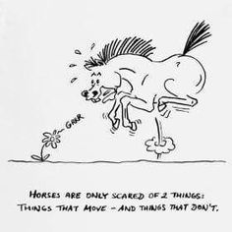
May 2022
Hi Everyone. Yes, it’s May already and here are a few things we have been up to. Don’t forget to drop me a line if you have done anything exciting with your horses recently, like Susie Reed who sent the following…

“As you asked for things we are doing with our horses, I thought I would send you my and Jane’s walk out with Babs & Jaspa a few Sundays ago. We let them do their own thing up on Rockford common. They were quite happy to stay with us and munch on the tasty heather” 😂😂😂

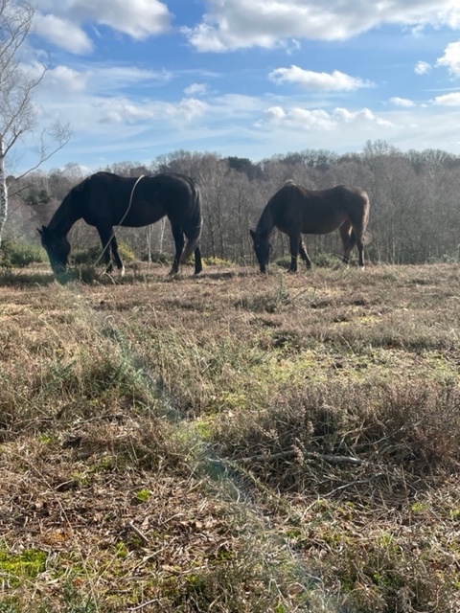
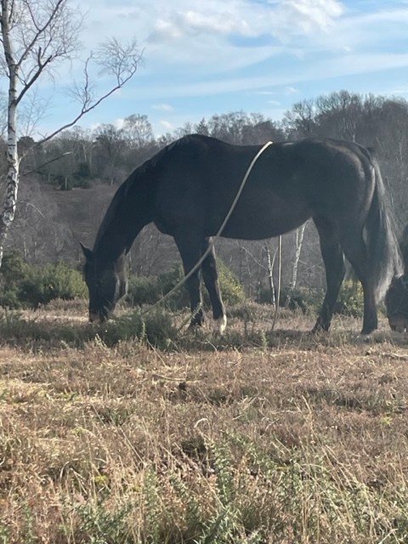

Stuff that’s happened…

Sunday 6th March – Dressage Pilates Clinic, Folds Farm
The Dressage Pilates Clinic with Helen Dawes seems to have given those who attended food for thought. The lovely Sue Vass reports as follows…
“I hacked over to Folds Farm from Downton and it was a pleasant ride until we met a flock of Guinea fowl - Duchess's nemesis! A kind motorist stopped and helped us get past the "monsters"! The clinic was quite a revelation. Helen Dawes was very astute and, despite the copious layers of clothing I was wearing, could identify my faults in position. She advised me to turn my pelvis in the direction I wanted to go, I have a tendency to follow the horse, which does give the desired result. I am also a terrible sloucher, so sitting up straight is something I must continually work on. The teaching was kind and sympathetic and the session showed me how my every move affects my very sensitive horse. My companion Abi with her horse Elsa, also benefitted from the clinic with advice about the position of Abi's hands, something which she is continuing to work on. Thanks to Pauline for organising such an interesting event”

Saturday 26th March – Fun Quiz at Greenfields, North Gorley
Well I think I can say that a fabulous evening was had by all! A very big thank you to Tanya and Andrew for hosting the event in their amazing cosy barn. Our quizmaster, Andrew, was on top form as usual and definitely got our brains ticking with some very tricky questions!!!

The victorious team was the Big Fact Hunt (pictured), while the wooden spoon went to You’re Joking (naming no names).
The pizzas supplied by Luigis were delicious and to top it all, the raffle and silly games managed to raise an amazing £174 for the Ukraine Appeal – A win win all round!!
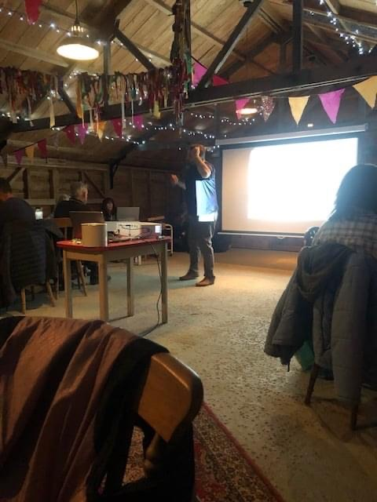
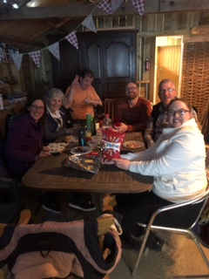

Saturday 9th April – Equine Massage Demo at Cherie’s Yard, Brunes Perlieu Lane
The Equine Massage Demo proved to be a popular event and Pippa Hutton shares her experience of the day…
“A chilly but sunny morning saw a group of Gorley Vale members and guests convene at Cherie’s hidden gem of a yard in Godshill to meet Louise Cooke, a qualified Equine Massage Therapist. The benefits of massage for our equine friends are extensive. Massage improves circulation and efficiency of muscles, increases the range of motion and reduces risk of injury. It also enhances general wellbeing, helping your horse to relax and allows you to bond together. If you massage your horse regularly (once a month is optimal) you will learn to notice when something feels abnormal, tight or tender. Then you can call in a professional before it becomes a bigger issue.
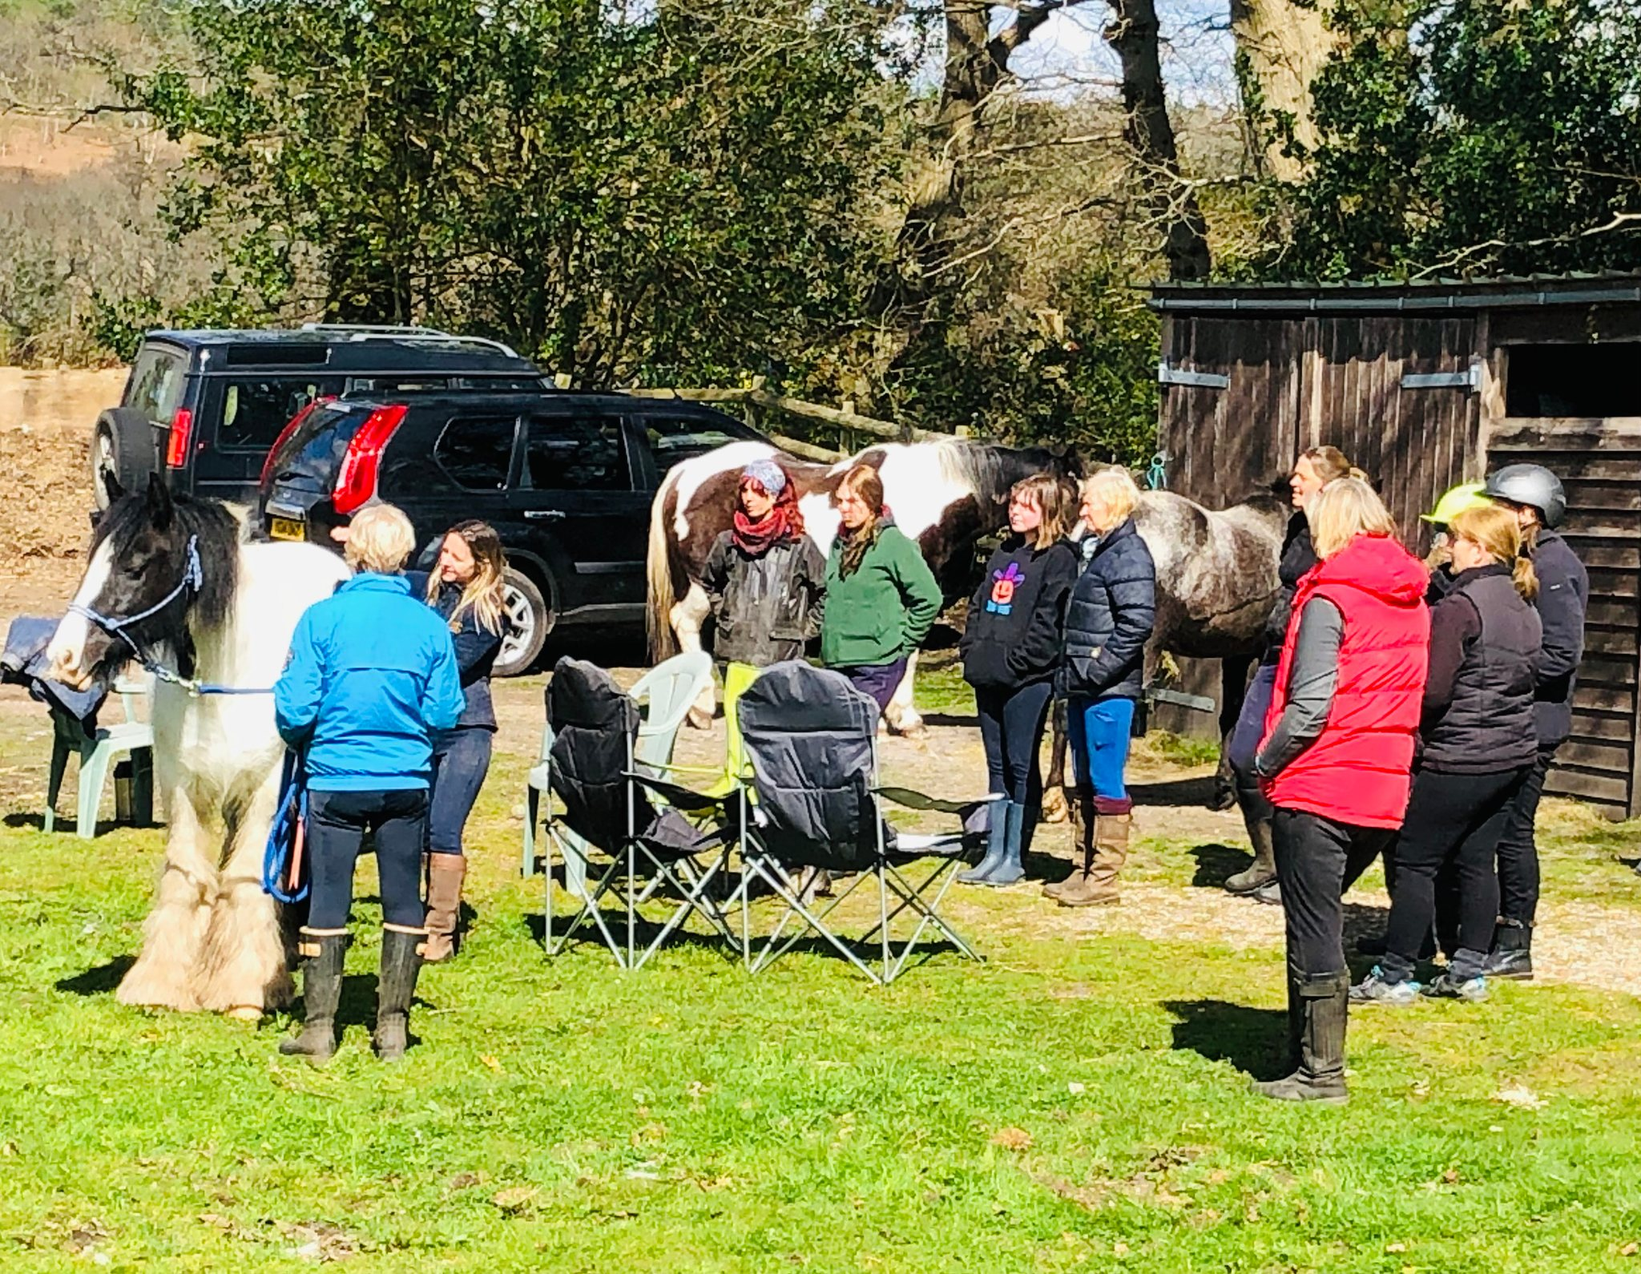
Ably aided by Tonto, Louise balanced the session beautifully between bite-sized chunks of theory, demonstrating techniques and us getting hands-on with our own horses. Thank you to Debbie Cooke for her great organisation skills and lending Tonto, Cherie for lending her yard and letting my guests practise on Molly, and Louise for her patience and willingness to share her knowledge 😊. If you have any questions or would like to book your horse in for a body work session with Louise, please get in touch with her via mobile: 07876 820379 or email: louisejcooke@gmail.com”

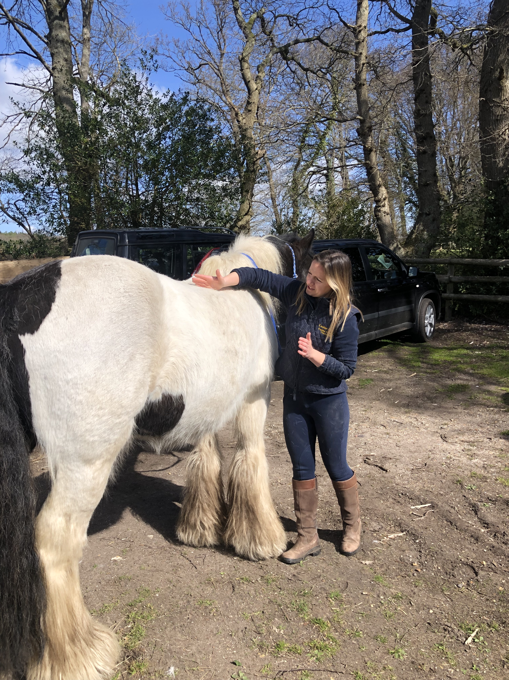

Saturday 30th April – Bluebell Ride, Burgate
Well weren’t we lucky. We were blessed with a beautiful day and to Brenda’s amazement, everyone was early! Our group of eight (Mark, Nikki, Alex, Susie, Andrew, me, Ande (Brenda’s lovely neighbour and our newest member), led by Brenda) set off to Breamore House where we were joined by Sue. The bluebells didn’t disappoint and it was like a purple carpet weaving through the woods. We continued to the MizMaze and then on towards the downs with spectacular views for miles around. Our endurance riders (Mark and Nikki) split off at the downs to enjoy the gallops and caught us up later.
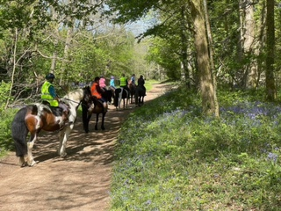
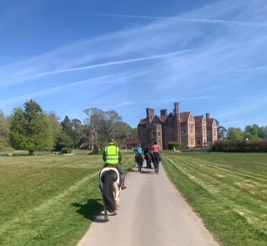

Everyone arrived back at Brenda’s safe and sound, with big smiles all round and ready for coffee, tea and biscuits. A big thank you to Brenda for hosting a fab event.
Top Gossip for the day: Mark revealed that he had just proposed to Nikki at the top of a mountain on a skiing trip and she said YES!!! Congratulations to you both on your engagement from all at GVRC
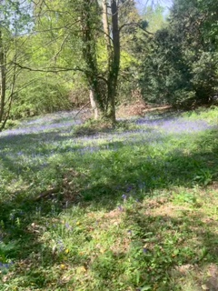

Stuff that’s happening…
Saturday 7th May - Coach Trip to Badminton Horse Trials
Great news! Tickets have been purchased and the minibus booked. We are off to Badminton tomorrow. Hoorah!!
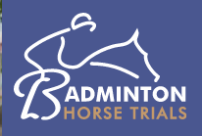

Saturday 21st May - Polework & Jumping Clinics, Wick Farm, Downton
Polework and jumping clinics with the lovely Anna Noble to suit all levels. The cost is £20 per person (Ref: Anna Noble). Please contact Sue (sue.vass.email@gmail.com) to book your place.

Friday 24th to Sunday 26th June - Fun Camp at Brenda’s Fields, Burgate
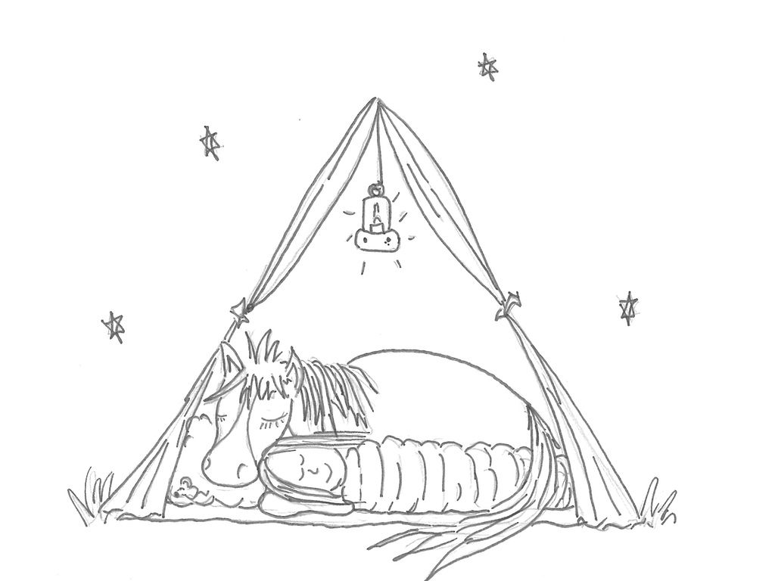
NEWSFLASH!! Well, the committee has got together and come up with a few ideas for camp and we think it will be a fun filled weekend!

Arrive on Friday afternoon/evening to set up corrals and settle down for a self-funded takeaway and a few bevvies and a catch up OR turn up on Saturday morning.

Saturday will be a fun day incorporating:
- Polework and jumping clinics with our lovely instructor Trudi
- Liberty work and obstacle practice with Brenda.
- Talk/demo
- Tina’s craft corner
- Evening BBQ

If you still have plenty of energy on Sunday, there will be a:
- Treasure hunt
- Dressage with obstacles competition
- Afternoon cream tea

The cost is £80 per person (Ref: Camp) and to book your place, please contact Brenda on 07803 387560 or email pootlin@hotmail.com

Sunday 17th July - Polework & Jumping Clinics, Folds Farm
Choose from a Polework Clinic offering some interesting gridwork or a Jumping Clinic if you are feeling brave, with the lovely Nikki Green. To be held at Folds Farm. £18 each (Ref: Nikki Green). If you are interested, please contact Cherie (greencherry.68@btinternet.com)

Saturday 20th August - Tack Sale/Equestrian Car Boot, Brenda’s Field, Burgate
Come and grab a bargain at our Tack Sale at Brenda’s field. This will be opened to the general public so if you have any horsey friends who are totally overstocked or in need of items, please let them know. Cake and refreshments will be available of course!! Time to be confirmed. £5 per table (Ref: Tack Sale). Contact: Jo (jo@thehouseoflawrence.com)

Still to come…
Other possible events in the pipeline for this year include…
- a visit to the Sampsons to hone our driving skills
- Cross country schooling at Tenantry
- Horse agility
- Your Horse Live coach trip
- Equine simulator
- Christmas Gathering
…Amongst others!! Watch this space.

And finally…
Challenge Gorley Valers!!
Yep this is where Debbie gives us a challenge and this time it is all about the figure of 8!
Non ridden
Ask your horse to walk a figure of 8. Place 2 cones or markers around 12ft apart and ask your horse to walk a figure of 8 around the cones.

Tips;
If you've never tried this before, break it down.
Teach/practice sending your horse away from you - to send your horse to the right, direct your horse's nose out and away with your right hand and use your left as the accelerator.
Send your horse around one of the markers.
Practice changing direction.

For those that find this easy or would like more of a challenge, try this at trot or at liberty.

Ridden
Ride a figure of 8 one handed. Cones can be used as a visual aid for you if you prefer, but no markers needed if not.

Tips;
Again, break it down.
Make sure you can ride a figure of 8 using both hands. If this is difficult, use exaggerated aids to begin with. To turn right, look right, open right rein wide and outside leg on and to go left, open left rein and right leg on.
Ride with your hands closer to your horse and open rein slightly if needed and touch outside rein on their neck, still using your legs as before.
Ride with hands together, using leg aids as before.
Ride one handed with knuckles facing forwards and using your index finger and little finger to go left or right, leg aids as before.

More challenging...ride the figure of 8 with no reins at all!

Have fun! It would be great to see or hear about your progress on our Facebook page.

Happy riding!
Sharon x

Bank details for payments are as follows…
Sort code: 30-97-08 Account no: 01404126
Please make sure you put the appropriate reference otherwise it is exceedingly difficult for Debbie, our wonderful treasurer, to keep track of who has paid what for when!!!

