Gorley Vale Riding Club Newsletter
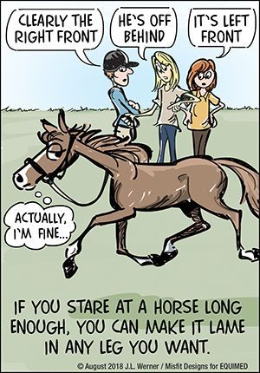
October 2022
Hi All. Yes, it’s that time of year – Membership Fees for 2023 are now due! Being held at the 2022 rate of £23 per person, I’m sure you will agree that it’s great value for money. Also, if you pay before 10th November, your meal at the AGM will be subsidised (see below for details). Please make payment into the GVRC account (Ref: Membership). Many thanks

Meanwhile, one of our newer members, Marlies Koutstaal, and her lovely horse, Lady Grey (AKA Sox), competed in the Ipley Horse Trials hosted by the New Forest Hounds at Ipley Manor near Marchwood on 18th September. Well done Marlies! She reported:

“It was a beautiful day and the going was very good due to some rain the week before. We had a clear round in the Novice class (60cm) with 23 jumping efforts and finished 6th. Unlike me, who - having crossed the finish line still aboard - was ready to collapse on the couch with a large G&T, Sox wasn't even blowing and would have happily gone another lap. Looking forward to the next outing! “

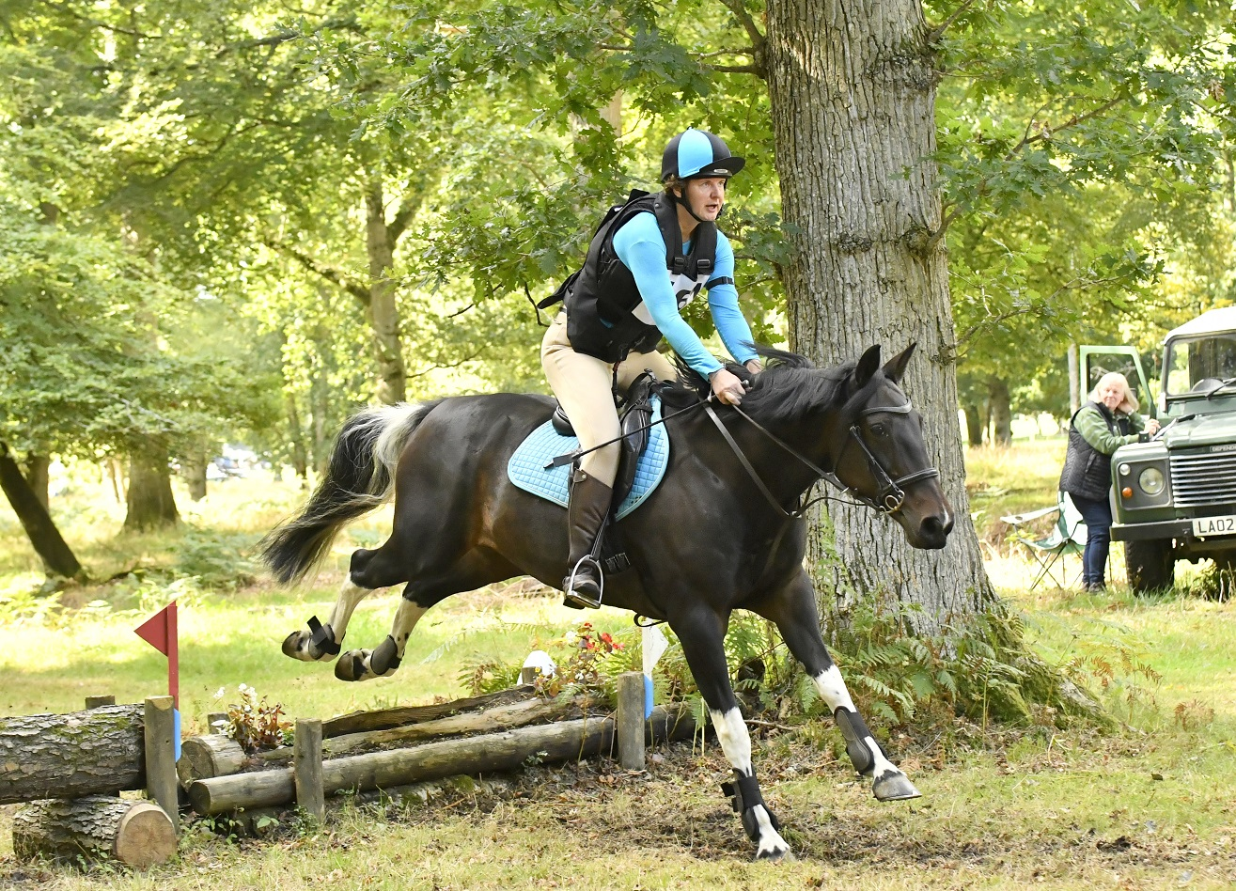

Here are a few things the club has done recently…

Stuff that’s happened…

Saturday 3rd September – Hampshire Horse Agility Clinic, Hockey’s Farm, Gorley
The Agility Clinic proved very popular with a good turnout. Here’s Cherie’s take on the day:
“Hockeys farm – toilet, shop, café…. Cakes!! What a great venue… lovely big flat field to work in which comfortably accommodated 4 horses in the session, with numerous goes on the equipment and tons of parking.
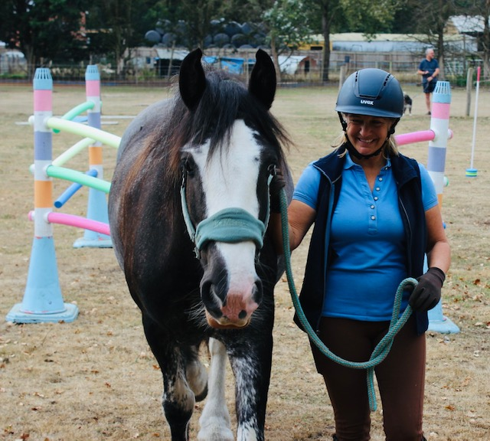
I felt our young horse Mollie would benefit from this so I hacked over with Suzanne and, although it was quite a long way from Godshill, it was a good and doable ride. We dismounted, untacked, put headcollars on the horses and led them into the session field where all sorts of interesting obstacles awaited.

There were strings of colourful plastic hanging balls, a road traffic walkway with scary signage, hoops and tunnels to walk through, a ramp and a seesaw! Things that swung, bumped the horses sides, flapped in the wind and reflective,…Mollie spent a considerable amount of time surveying herself in a propped mirror and there was a black, very reflective water tray – which she had a good drink from! before putting her trust in me and walking through it like a pro…

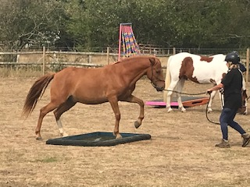

Lucy and her team were constantly on hand to help and advise. Lucy’s partner was busy taking lots of photos and I found it really helpful to look back on the photos at Mollie’s facial expressions where she was working things out. Lucy is IRT trained and has a lot of natural horsemanship tactics up her sleeve to solve any issues. The overriding feel I got from the session however was just how completely calm it was. I found the helpers were there if needed, checking you were okay but allowing you and your horse to bond and build trust. I would say this would be suitable for any horse – young or established. It makes them think and look to you for reassurance. The obstacles varied in difficulty and there was plenty of room to keep trying on one particular one for longer if you needed to. There was absolutely no pressure and Mollie thoroughly enjoyed her hour long experience. I will definitely do this again when the team are back at Hockeys in the spring and I thoroughly recommend it.”
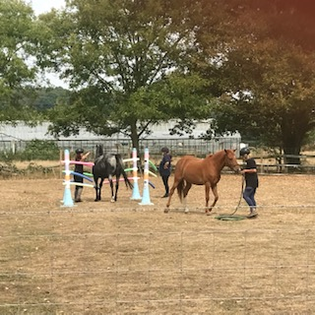
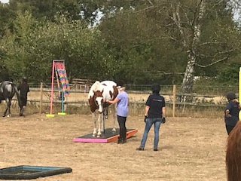
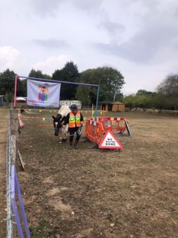

Tuesday 13th September - Jumping Clinic, Brenda’s Fields, Burgate
Just four of our lovely members (Tina, Tanya, Brenda and Alex) decided to put their brave pants on an do the Jumping Clinic with Trudi. Here’s what Tanya had to say about the event:

“So, we had a jump clinic booked with Trudi at Brenda's fields. The weather on the day was pretty grim; rain, squally rain, drizzle, rain... I do ride in most weathers but was thinking maybe it was a bit too soggy to be bothered to drive over to my field, walk a wet and grumpy pony up a boggy hill to load, then travel to Brenda's to stand in the rain waiting for my turn to jump. Well, I am really glad that I did because it was a great clinic!!

Tina kindly took us in her flash new trailer, we met in the wet field, walked up in the rain, Honey and Chica loaded happily as usual and off we went, still raining! We arrived a bit early and left the ponies in the trailer until Trudi arrived, still raining we tacked up, mounted and yey, the rain stopped!
Trudi set out an interesting twisty course of small jumps, designed to get us to concentrate on consistent rhythm round the course and over the jumps. We were asked to count strides out loud between the related distance fences. Trudi gives feedback and works with you to ride more effectively and improve your round. We all thoroughly enjoyed it and Chica and I definitely made progress. Oh, and once finished, we dismounted, put the kettle on for a coffee and it started to rain!”

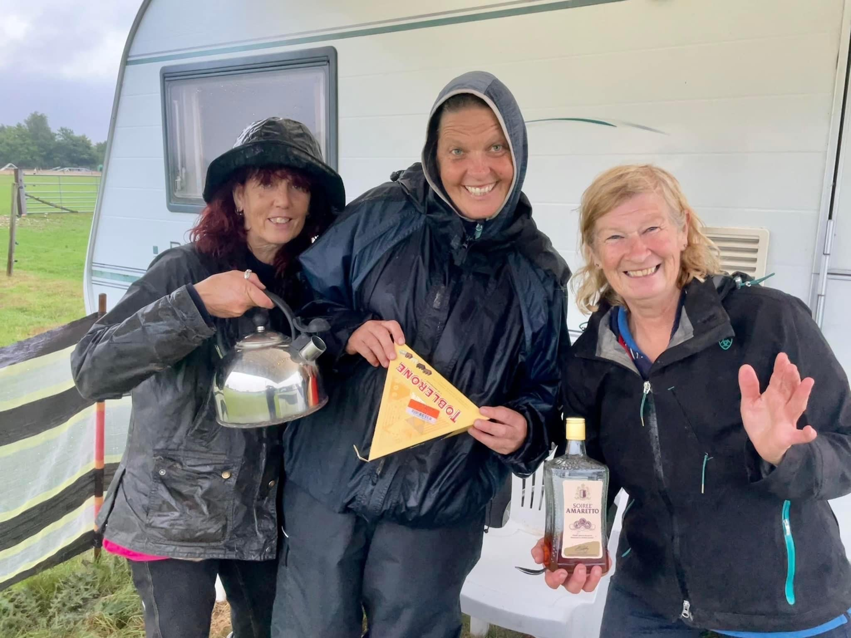

Sunday 9th October – Massage Clinic at Tom’s Field, Godshill
Unfortunately, we had to cancel this event due to a lack of interest.
Stuff that’s happening…
Saturday 29th October – Emma Massingale Performance at Kingston Maurward Equestrian, Dorchester
Although not a GVRC event as such, we thought we would let you know that some committee members are interested in going to see Emma Massingale, a free rider/adventurer who works with herds of horses at liberty – her motto: No reins No rules No limits. Starting at 3pm, it will be a couple of hours of fun and entertainment, watching Emma and her amazing horses at work, rest and play. Café/refreshments are available. Tickets are £35 each, available from her website (www.emmamassingale.com). Make your own way there or if you would like to car share, please contact Sharon (Sharon.rupertbear@hotmail.co.uk) and we will try to arrange it.

Sunday 30th October – Spooky Halloween Gathering, Greenfields, North Gorley

Unfortunately, due to new rules from the Forestry Commission, we are unable to ride to the event this year, so sorry but NO HORSES! However, the fun and games will go on, starting at 12.30pm, so get cracking with your costumes! Bat soup and evil cakes (by evil we mean calorie laden!) provided. The cost is £10 per person (Ref: Halloween). Contact: Tanya (sunshine.gardens@yahoo.co.uk)

Thursday 10th November – Annual General Meeting, The Horse & Groom, Woodgreen
Starting at 7pm, we promise to keep the meeting as short as possible (as usual) and then have a lovely social gathering. The main meal options are:

- Fish & Chips
- Burger & Chips
- Move the Mountain Burger & Chips (veggie/vegan)

…followed by either:

- Fruit Crumble
- Sticky Toffee Pudding
- Ice Cream (2 scoops)

The cost is £18 per head (or £10 per head if you are a fully paid up 2023 member before the AGM) and MUST be paid in advance please (Ref: AGM). The contact for booking and confirming your food orders is Sharon (sharon.rupertbear@hotmail.co.uk)

Saturday 19th November – Alternative Valentine’s Ride at Redlynch
Come and enjoy a morning fun ride, almost all off-road with far reaching views, with chocolates and prosecco to finish! What’s not to like?! Armed with a map and a

clearly marked route of the tracks and grassy bridleways on the downs, you can enjoy the ride at your own pace in pairs or small groups. Time slots to be confirmed on booking. Please note there is off-road parking on wide verges with no reversing required!! £5 per person (Ref: Valentines Ride). Contact: Wendy (wtreble@btinternet.com)

Saturday 10th December - Christmas Gathering, Brenda’s Fields, Burgate
Unfortunately, we are unable to hold a spider ride across the forest this year, as we won’t get the necessary permits from the Forestry Commission in place in time. However, get the date in your diary and your tinsel and fancy dress outfits ready! Brenda has kindly offered to host, so join us for a ride out and then enjoy sausage baps, mulled wine and mince pies! The cost is £10 per person (Ref: Xmas). Contact Brenda (pootlin@hotmail.com)
And finally…
As most of you know, we usually nominate 3 charities at the AGM and give a small donation to each. In these extraordinary and difficult times, do you know a charity that you would like to put forward? All suggestions welcome! If you can’t make the AGM, please email our wonderful secretary Cherie in advance (greencherry68@btinternet.com).

Also, don’t forget that we need a new Treasurer and a PR/Advertising/Website/Social Media Whizz. Do you feel up to the challenge?

Happy spooky Halloween!
Sharon x

Bank details for payments are as follows…
Sort code: 30-97-08 Account no: 01404126
Please make sure you put the appropriate reference otherwise it is exceedingly difficult for Debbie to keep track of who has paid what for when!!!

